|  |  |  |  |
| --- | --- | --- | --- |
|  |  | | |
|  |  | | |
| Project: | UTA Alert  Gauri Anil Wagle, Ankur Goyal, Divender Murtadak, Juhitha Reddy, Abhilash Reddy N  CSE 5324 – Spring 2014 | | |
| Module: | Detailed Design | | |
| Deliverable: | Design Document | | |
| Version: | [2.0] | Date: | [03/23/2014] |

Prepared by:

Gauri Anil Wagle, Ankur Goyal, Divender Murtadak, Juhitha Reddy, Abhilash Reddy N

Revision History

| Version number | Date | Originator | Reason for change | High level description of changes |
| --- | --- | --- | --- | --- |
| 2.0 | 02/14/2014 | Gauri Anil Wagle Ankur Goyal Divender Murtadak | Initial draft | Initial Draft |
| 2.1 | 02/21/2014 | Juhitha Reddy, Abhilash Reddy N | Addition of f content | Addition of content |
| 2.2 | 02/23/2014 | Gauri Anil Wagle Ankur Goyal Divender Murtadak | Final Document | Addition of content |
| 2.3 | 03/24/2014 | Juhitha Reddy, Abhilash Reddy N | Addition off content | Addition of content |
| 2.4 | 04/14/2014 | Gauri Anil Wagle Ankur Goyal Divender Murtadak | New Functionality added | Addition of content |

Contents

1.Overview 4

Purpose of the Document 4

Scope 4

2.High Level Entities 4

Actors 4

Communication Channel 4

Use Cases 4

Work flow 5

3.User Interface 7

Home Screen 7

4.Assumptions and Risks 7

Assumptions 7

Risks 7

# **Overview**

## **Purpose of the Document**

The main purpose of this document is to describe the design details of UTA Alert Mobile application.

UTA Alert ensures safety of people in distress situation. Advanced mobile technology enables victim to communicate with people easily, describe their problems well and let concerned officials act upon the situation more efficiently. The app will enable the victim to ask for emergency help within few seconds and improves the possibility to avoid the crime very significantly.

## **Scope**

The scope of this project is to develop a user friendly app having following functional features:

* Ability to make calls
* Ability to send message
* Ability to obtain GPS location
* Ability to add attachment to message
* Allow user to add contacts
* Ability to use power button to activate application

# **High Level Entities**

## **Actors**

Victim, 911 Department, UTA police, Guardian

## **Communication Channel**

Message (SMS, MMS), that contains victims location and necessary information.

Call to Emergency Contacts

## **Use Cases**

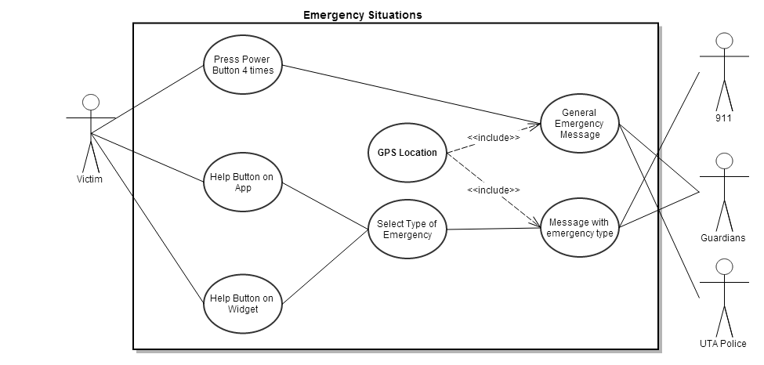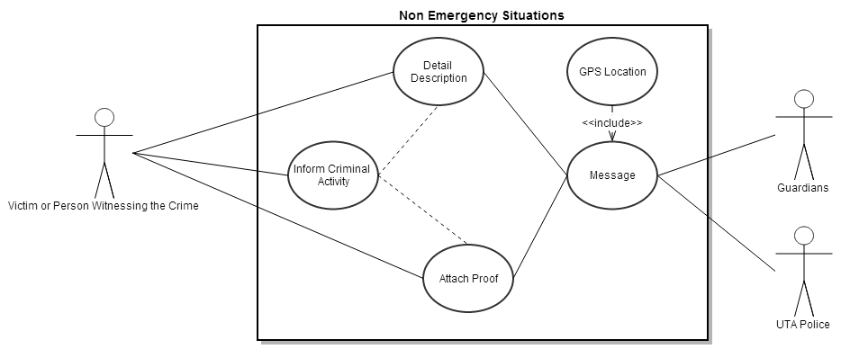

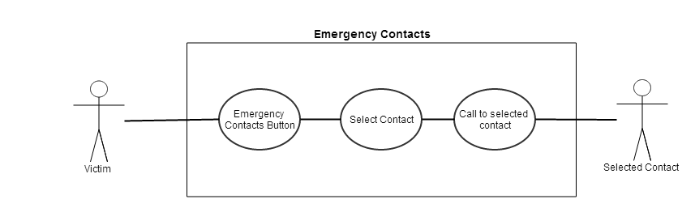

## **Work flow**

There are three flows in our application.

* Emergency Situation
* Non-Emergency Situation
* Emergency Contacts

**Emergency Situation (Activity1** Press_power_button**, Activity2** press_widget**)**

Activity1:

Step1:

In case of Activity1 application captures the location of victim and encode it and sends to configured numbers , 911 and UTA police.

Step2:

* Guardian reaches to the location contained in message and handles situation.
* UTA police also find the location and send cops to victim's location.
* 911 decodes the message and sends the cops to that location.

Activity2:

Step1:

If user presses emergency widget then next screen captures the type of emergency and with the encoded location, message is sent to concerned department.

Step2:

That department takes necessary action based on the type of emergency.

**Non-Emergency Situation (Activity** Inform_criminal_activity**)**

Step1:

User clicks on Inform_criminal_activity button and feeds the information about the incident.

In this option user can attach the snaps of the incident which will help the concerned department to solve the case efficiently.

Step2:

Necessary action is taken by the department.

**Emergency Contacts (Activity** Emergency_contacts_activity**)**

Step1:

User Clicks on Emergency Contacts button and selects a contact from the list of contacts.

Step2:

A call is initiated to the number of the selected contact

# **User Interface**

**Home Screen** **Non-Emergency Screen**

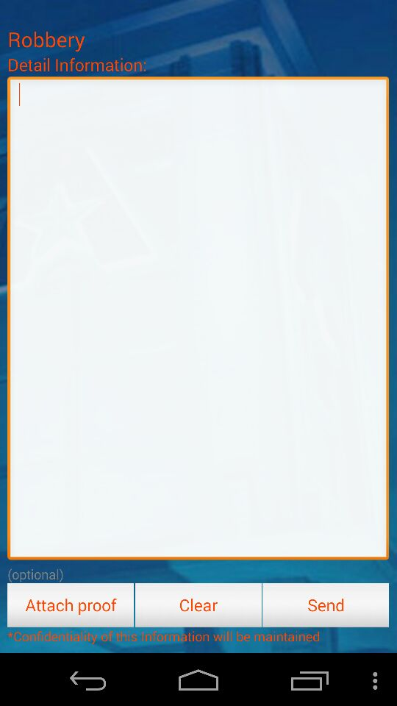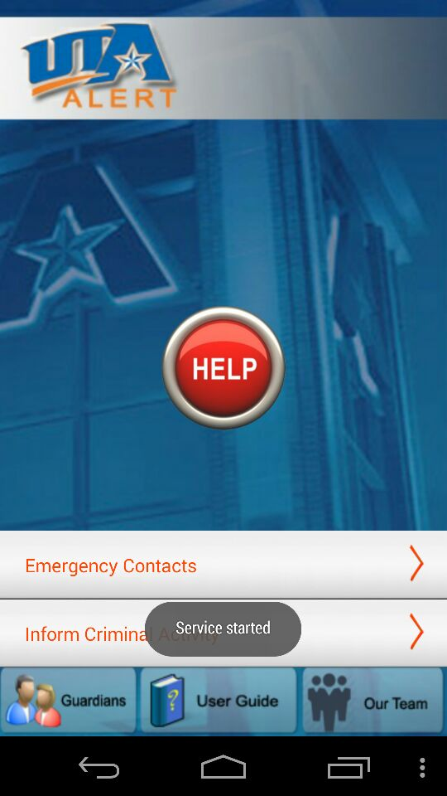

## 

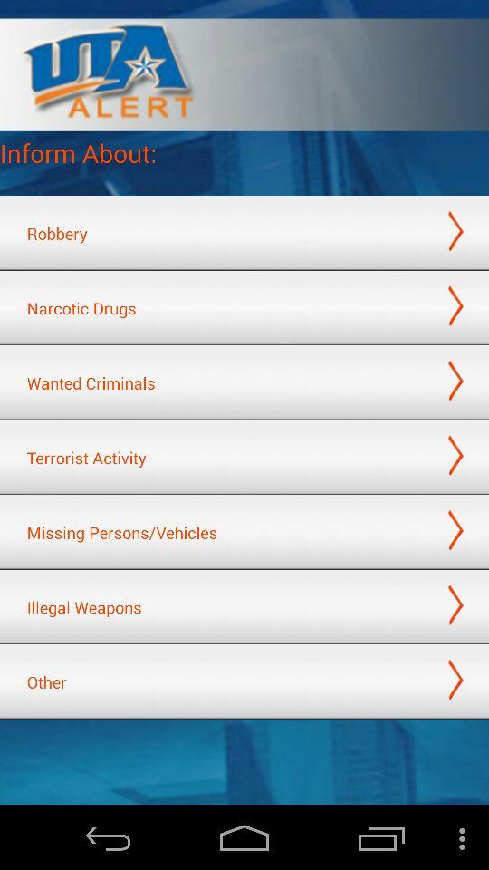

# **4. Assumptions and Risks**

## **Assumptions**

There are following assumptions in the design:

1. The GPS of the phone will give correct location
2. The Guardian and Police have access to the message and will respond promptly
3. The user will have a Network provider and SMS/MMS service activated on their mobile device

## **Risks**

Following are the risks in the design:

1. Ability to deactivate the message send by mistake.
2. The guardian, Police and 911 should response immediately on message sent by victim.